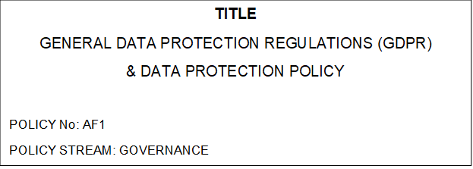

GENERIC POLICY STATEMENT:

This information is designed to reflect and promote the best practice of DSJ Hypnotherapy. Issues relating to this policy should be notified to the appropriate policy stream lead.

REFERENCES:
Human Rights Act 1998
Freedom of Information Act 2000
Guide to the General Data Protection Regulation: ICO November 2017 EU
General Data Protection Regulation: General Information Document
The Data Protection Act 2018
AUTHOR:
Donna Jones

INTRODUCTION:
The General Data Protection Regulations (GDPR) became applicable from 25 May 2018
and apply to all EU member states. The Data Protection Act 2018 sets out mandatory
principles applied to all organisations that hold or process personal data in the UK. The
Act provides a comprehensive and modern framework for data protection in the UK in
accordance with the GDPR.

DSJ Hypnotherapy is responsible for appropriately managing personal data and direct
communications on behalf of anyone who provides personal details.

DSJ Hypnotherapy needs to demonstrate that the organisation makes good decisions and is accountable for the collection and use of personal data. In order to do this DSJ Hypnotherapy will comply with the law in respect of the data it holds about individuals and regularly review this policy in response to new interpretations of legislation.

PURPOSE OF POLICY:
The purpose of this policy is to ensure personal information received or obtained by DSJ Hypnotherapy is managed and used responsibly, securely and fairly and in accordance with
data protection legislation.

POLICY STATEMENT:
DSJ Hypnotherapy will meet legislative requirements by maintaining an awareness of responsibilities, as appropriate, in accordance with the requirements of General Data Protection Regulations (GDPR) and the Data Protection Act.

REGULATORY ENVIRONMENT AND LEGISLATION:
DSJ Hypnotherapy is obliged to abide by all relevant UK and European Union legislation.
DSJ Hypnotherapy will comply with the following (and any other appropriate) legislation:
• The Data Protection (Processing of Sensitive Personal Data) Order 2000. (GDPR) (Regulation (EU) 2016/679) (2016)
• The Data Protection Act (2018)

SCOPE:
This policy applies to all staff within DSJ Hypnotherapy at any location or in any
capacity.
Third parties providing services to DSJ Hypnotherapy under contractual arrangement
are also subject to the provisions of this policy.
It applies to all data held by Affinity Hypnotherapy pertaining to clients.

RESPONSIBILITIES:
All staff, whether permanent, temporary or contracted are responsible for
ensuring that they are aware of and comply with the requirements of this policy and the
policies, procedures and guidance produced to support it.

Key Terms

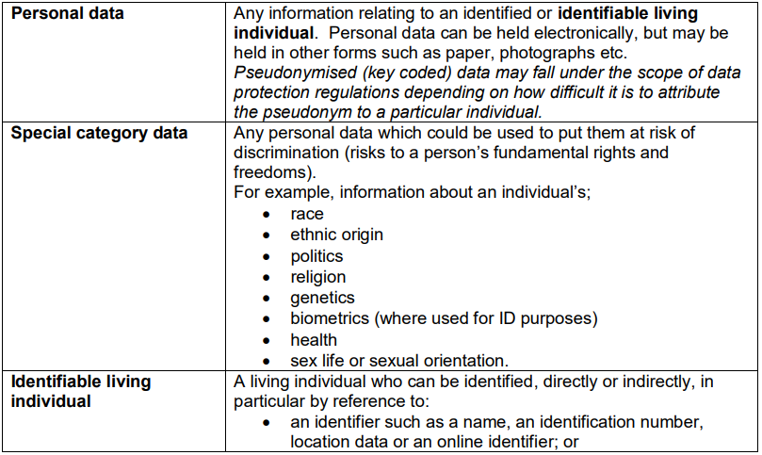

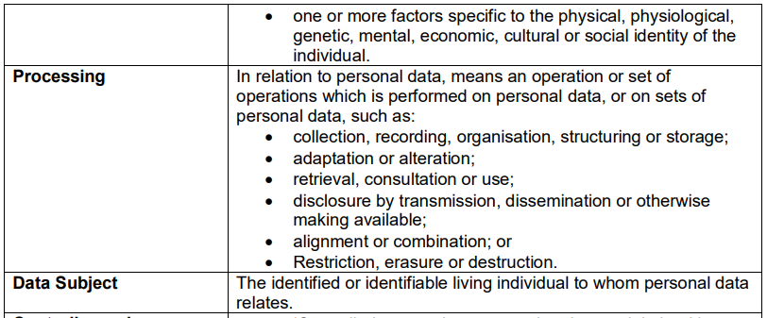

KEY PRINCIPLES:
The Data Protection principles requires that personal data shall be:
- Processed lawfully, fairly and in a transparent manner in relation to individuals.
- Collected for specified, explicit and legitimate purposes and not further processed in a manner that is incompatible with those purposes; further processing for archiving purposes in the public interest, scientific or historical research purposes or statistical purposes shall not be considered to be incompatible with the initial purposes (principle of purpose limitation);
- Adequate, relevant and limited to what is necessary in relation to the purposes for which they are processed (principle of data minimization)
- Accurate and, where necessary, kept up to date; every reasonable step must be taken to ensure that personal data that are inaccurate, having regard to the purposes for which they are processed, are erased or rectified without delay.
- Personal data shall be kept in a form which permits identification of data subjects for no longer than is necessary for the purposes for which personal data are processed.
- Processed in a manner that ensures appropriate security of the personal data, including protection against unauthorised or unlawful processing and against accidental loss, destruction or damage, using appropriate technical or organisational measures (principle of storage limitation and integrity and confidentiality).

ACCOUNTABILITY:
DSJ Hypnotherapy guidance with respect to the key domains of GDPR:
• Data Protection Officer (Data Breaches or requests for erasure or rectification)
GDPR/Data Protection Policy May 2019

DATA PROTECTION OFFICER: Donna Jones, founder of DSJ Hypnotherapy is the Data Protection Officer and is responsible for the monitoring of internal compliance.

DATA BREACHES: Donna Jones will investigate all reported instances of actual or
potential breaches of confidentiality and security and report to the Information
Commissioners Office. https://ico.org.uk/for-organisations/report-a-breach/

COMMUNICATION OF PRIVACY INFORMATION: DSJ Hypnotherapy adopts a lawful basis for processing and data retention.

LAWFUL BASIS FOR PROCESSING PERSONAL DATA:
DSJ Hypnotherapy has reviewed the content of the website and paper application forms to ensure
only the minimum data necessary is requested.

CONSENT: DSJ Hypnotherapy has a clear process for gaining consent via the appropriate forms
depending upon the data processing reason.

INDIVIDUALS’ RIGHTS: DSJ Hypnotherapy acknowledges individuals’ rights under GDPR and
have considered our procedures to ensure we can respond to requests. Requests can be
made verbally or in writing and will be forwarded for review by the Data Protection Officer

AUDIT: Adherence to this policy will be audited and measured against agreed standards set out by the Data Protection Officer as part of an annual business operations review.

